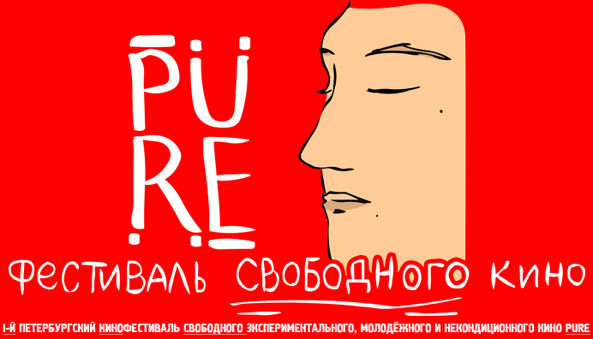
The application for the PURE 2018 film festival requires the completion of the following form:
Film Name:
Director(s):
Year:
Logline:
(annotation)
Nomination:
Genre:
Additional information:
(optional)
Duration:
(time)
Link:
(YouTube, vimeo or another hosting)
Countrie(s) providing the film:
City:
The person who sends this application has rights to this film:
(yes/no)
Number of distribution certificate in Russia (If have):
Email of director(s):
Phone number of director(s):
Film crew:
(If it was not indicated in the titles)
Do you authorize the use of your film, with attribution, as festival advertising by the administration of the festival:
(yes/no)
The completed application must be sent by e-mail PURE-FEST@MAIL.RU
Together with a screenshot from the movie and a photo of the director.
Deadline for applications: June 11, 2018 23:59
The festival will be held from the 1th to the 5th of August, 2018.
For more information, please visit the website PURE-FEST.DO.AM.

Good luck!
Administration of the film festival PURE
2018

